**System Configuration to execute RPA Bots**

**Document History**

|  |  |  |  |  |  |
| --- | --- | --- | --- | --- | --- |
| **Version** | **Release Date** | **Created By** | **Description of**  **Change** | **Genpact**  **Approval by** | **Customer**  **Approval by** |
| 1.0 |  |  |  |  |  |
|  |  |  |  |  |  |

**Terminology & Abbreviations used**

|  |  |
| --- | --- |
| Vendor / Supplier | Party who sells goods / provides services to **customer name** |
|  |  |
| IE | Internet explore browser, compatible for AA bots |
| Display Settings | System Resolution should be well matched to execute the bot |
| RAM storage |  |

**TABLE OF CONTENT**

1 Introduction 4

2 Overview 4

2.1 High Level Manual Process Description 4

2.2 Target Applications 4

2.3 Process Prerequisites 5

2.4 Definitions 5

3 Process Diagram - 5

4 Mismatch management EDI Process Description 6

5 Scheduling of Activities 15

6 User rights and access 15

# Introduction

This document provides a detailed and step by step understanding of ‘System Configuration’. These system setups are required for executing the Automation anywhere bot in the computer. Main purpose of this setup is that the bot must run in the machine successfully without getting any compatibility issues and able to identify the elements properly.

# Overview

## High Level Manual Process Description

1. Kill all the background running process (.exe files).
2. Check the IE browser zoom size is 100%.
3. In case the default IE zoom size is not 100, modify the zoom size into 100%.
4. Similarly check the screen resolution in Display settings. If the resolution is not 1366 x 768, update into the same.
5. Verify the Ram size is enough in machine to run the RPA bots and for a good performance. If the RAM is insufficient send an email to appropriate person.
6. Get the Computer name from system information.

## Target Applications

The following applications / systems are necessary to have access to, in order to the system configuration.

1. Internet Explorer
2. Display Settings
3. Screen Resolution
4. Outlook
5. Required .exe files

## Process Prerequisites

1. Administration Access
2. Access to Microsoft applications –Outlook

## Definitions

1. **Vendor**

The ‘vendor’ is a party who is responsible for providing goods and services to the buyer. In this document, vendor refers to the businesses / service providers in the market who provide goods, utilities and other services to Delhaize.

# Process Diagram -

Below is the high level process flow showing step by step movement of System configuration.

Start

Kill all background running process (.exe files).

No

End

Check the Ram size, if RAM size is less than 16 GB

Get the RAM size and Computer Name

No

If the screen resolution is not compatible to run the bot

Get the screen resolution

No

Check whether the IE browser zoom size is 100

# 

# System Configuration Description

Steps required to be followed for system setup:

1. Kill all the background running process (.exe files).

Fig: 1.1 Task Manager – will show all the running process

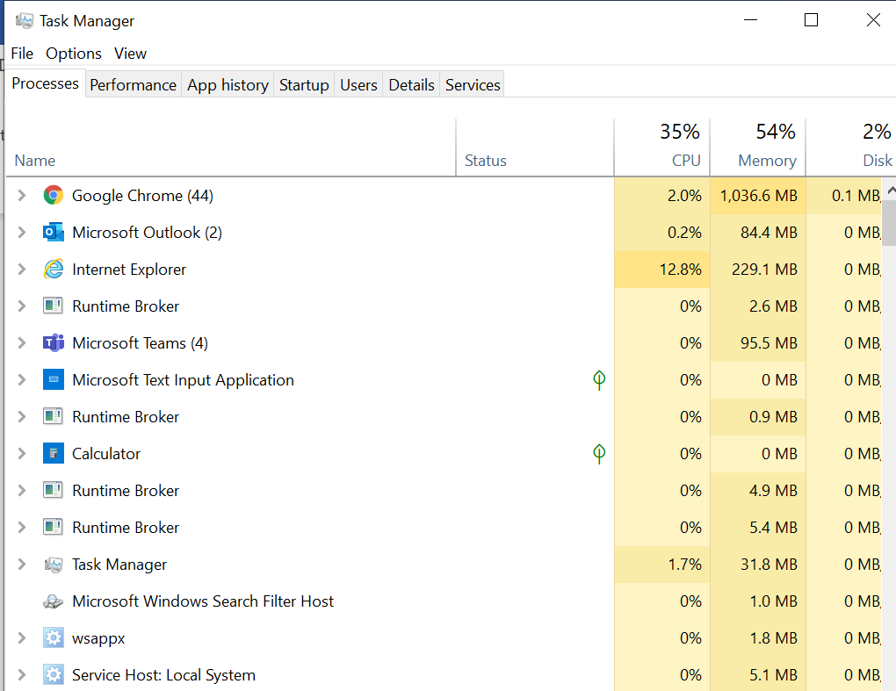

1. Open Internet Explorer

Fig: 2.1 IE



* + Click on the Settings option and navigate to Zoom size options.

Fig: 2.2 Zoom size tab

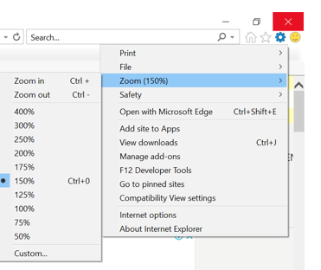

* + In case the default IE zoom size is not 100, modify the zoom size into 100%.

Fig: 2.3 Zoom size tab

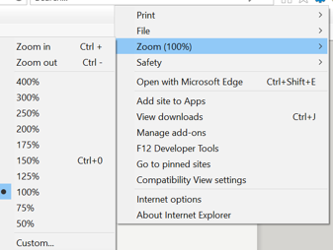

1. Open Display Settings to modify or verify the screen resolution

Fig: 3.1- Screen Resolution

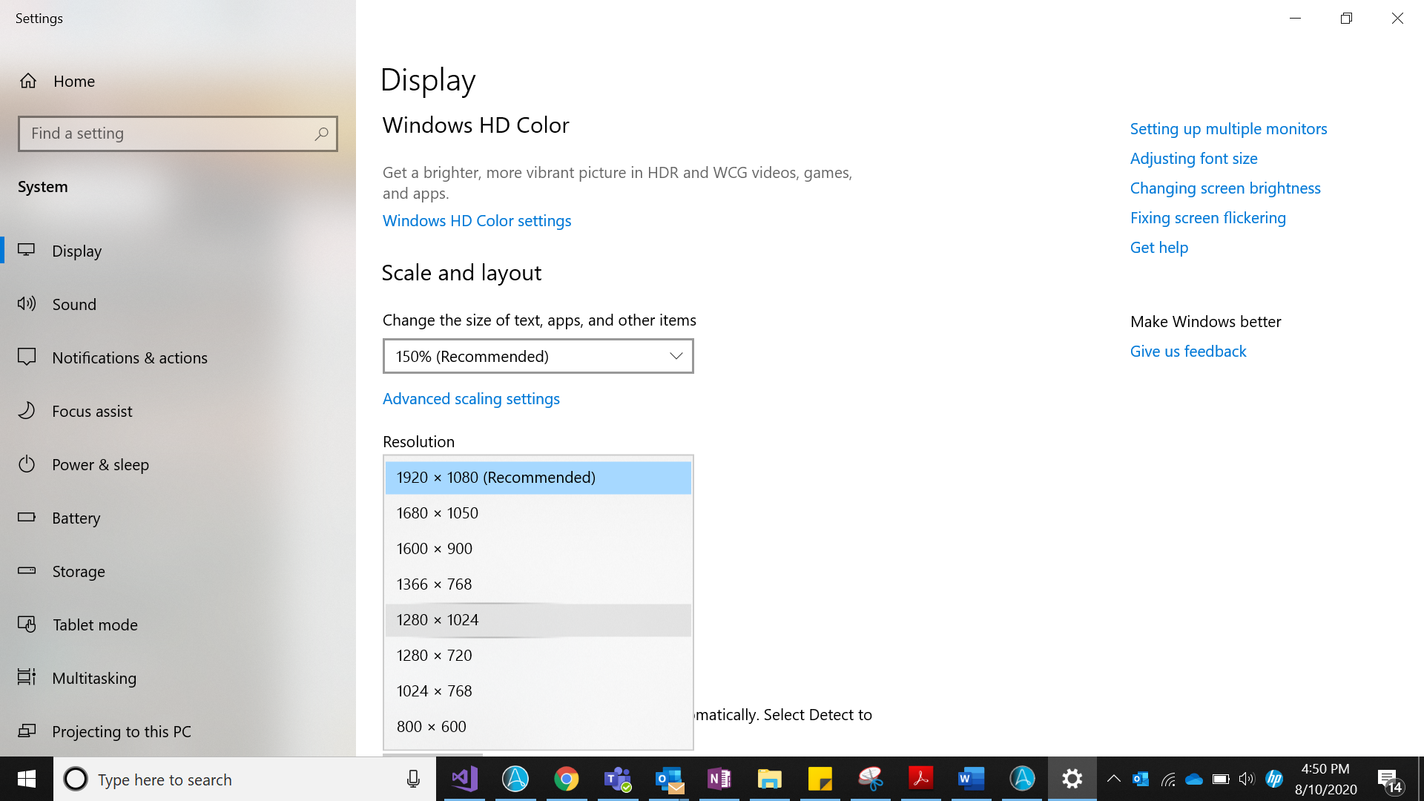

* + . If the resolution is not 1366 x 768, update resolution

Fig: 3.2- Compatible Resolution

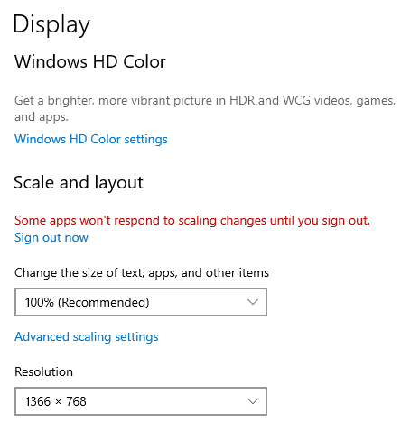

1. Verify the Ram size is enough in machine to run the RPA bots and for a good performance. If the RAM is insufficient send an email to appropriate person.
   * + Open control panel to navigate the System field

Fig. 4.1 – Control panel window

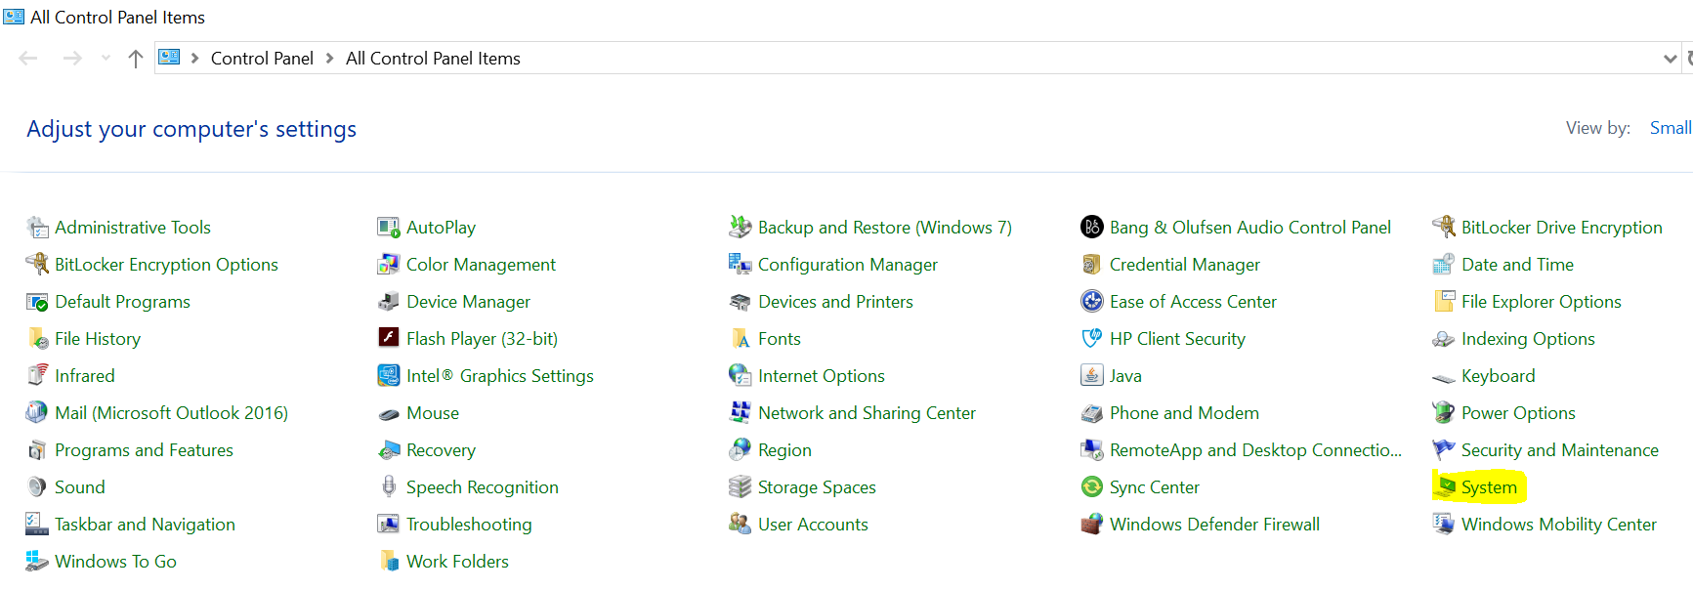

* + - Click on System to get the RAM size as well as Computer Name

Fig. 4.2 – System information

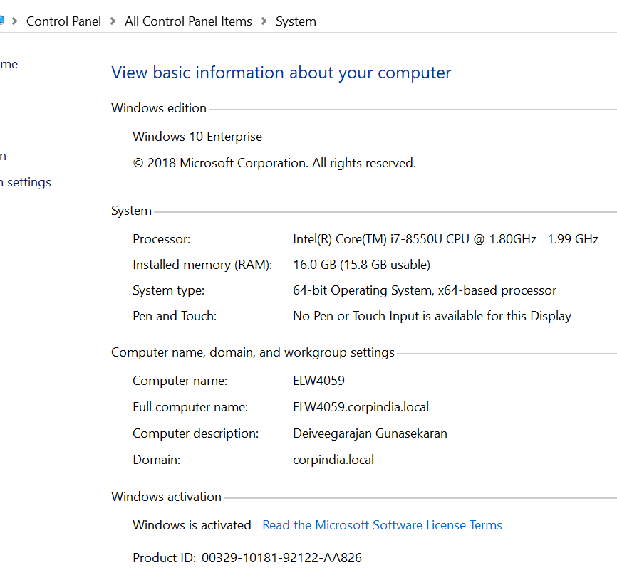

1. Send email to appropriate persons, if the RAM size is insufficient and it might have the performance issues.

Include the below details in email,

* + “Size of RAM”
  + “Computer Name”

Fig. 5.1 – Sample Email Template

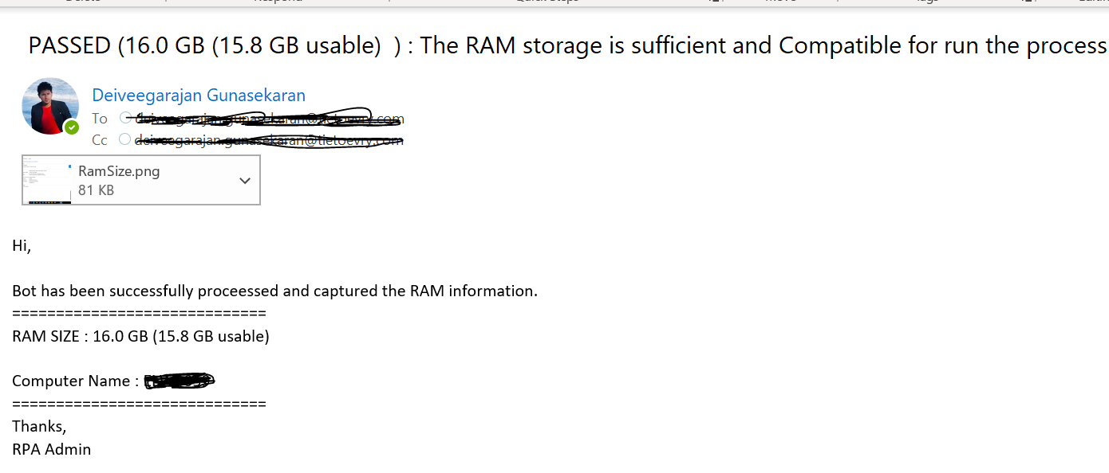

# Scheduling of Activities

The frequency of “System Configuration” is based on our requirements. If we need to do the setup on one-time setup, we can keep perform this setup. And, if we want the same setup to be executed each and every bot execution before running the scripts also it is possible to perform this setup.

# User rights and access

Kill all background running process (.exe files)

Yes

Yes

No

No

Yes

No

Check whether the IE browser zoom size is 100

Check the Ram size, if RAM size is less than 16 GB

Get the screen resolution

End

Get the RAM size and Computer Name

If the screen resolution is not compatible to run the bot